**LAB 7**

**7.1 Write a program to list the names of weekdays by using switch case. (USE OF BREAK KEYWORD IS MANDATORY).**

**SOURCE CODE**

#include <iostream>

using namespace std;

int main()

{

int weeknumber;

cout<<"Enter week number(1-7): ";

cin>>weeknumber;

switch(weeknumber)

{

case 1: cout<<"Monday";

case 2: cout<<"Tuesday";

case 3: cout<<"Wednesday";

case 4: cout<<"Thursday";

case 5: cout<<"Friday";

break;

case 6: cout<<"Saturday";

case 7: cout<<"Sunday";

default: cout<<"Invalid input! Please enter week no. between 1-7.";

}

return 0;

}

**OUTPUT**

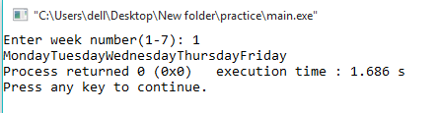

**7. 2 write a Program to Make a Simple Calculator to Add, Subtract, Multiply or Divide Using switch...case. (USE OF BREAK KEYWORD IS MANDATORY).**

**SOURCE CODE**

# include <iostream>

using namespace std;

int main()

{

char op;

float num1, num2;

cout << "Enter operator either + , - , * , /: ";

cin >> op;

cout << "Enter two operands: ";

cin >> num1 >> num2;

switch(op)

{

case '+':

cout << num1+num2 <<endl;

case '-':

cout << num1-num2<<endl;

case '*':

cout << num1*num2<<endl;

case '/':

cout << num1/num2<<endl;

break;

default:

cout << "Error! operator is not correct";

break;

}

return 0;

}

**OUTPUT**

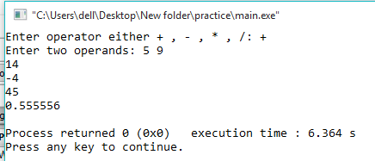

**7.3 Write a program in C++ to make such a pattern like triangle with number increased by 1**

**SOURCE CODE**

#include<iostream>

using namespace std;

int main()

{

int r, sp, p, no, n,j;

cout << "enter number of rows: ";

cin >> no;

n = no;

j=0;

for (r = 1; r <= no; r++) //for rows

{

for (sp = 1; sp <= n; sp++) //for space

{

cout << (" ");

}

n--;

for (p = 1; p <= r; p++)//for display values

{

j++;

cout << " " << j;

}

cout << "\n";

}

return 0;

}

**OUTPUT**

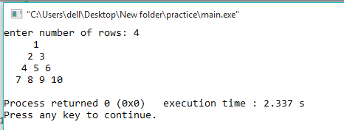

**7.4 Write a program in C++ to display the pattern like triangle using an asterisk.**

**SOURCE CODE**

#include<iostream>

using namespace std;

int main()

{

int i,j,k,n;

cout<<"Enter number of rows: ";

cin>>n;

for(i=1; i<=n; i++)

{

for(j=1; j<=n-i; j++)

{

cout<<" ";

}

for(k=1; k<=(2*i)-1; k++)

{

if(i<n)

if(k==1 || k==(2*i)-1)

cout<<"*";

else

cout<<" ";

else if(i==n)

cout<<"*";

}

cout<<endl;

}

return 0;

}

**OUTPUT**

